Working Group 4: What knowledge and skills will a university math instructor in 2030 need

Working Group Description:

What knowledge and skills will a university math instructor in 2030 need to safely navigate their and their students’ well-being in the context of learning mathematics?
How to understand, and possibly benefit from, the changes that each new generation brings?
Team teaching?
What kind of graduate training would be the best to prepare a future first-year math teaching faculty?
What expectations will there be from a first-year mathematics instructor - pedagogical, scientific, technological, societal?
What will be the role of a teaching faculty in the dynamics between mathematical and educational research: a boundary point that belongs to both or an isolated point?
Group Members:
- Lauren DeDieu, group leader (University of Calgary)
- Chunlei Ge (University of British Columbia Okanagan)
- Spectrum Han (University of British Columbia Okanagan)
- Asia Matthews (Quest University)
- Vilma Mesa (University of Michigan)
- Anton Mosunov, group leader (University of Waterloo)
- Yas Yamin (University of British Columbia Okanagan)

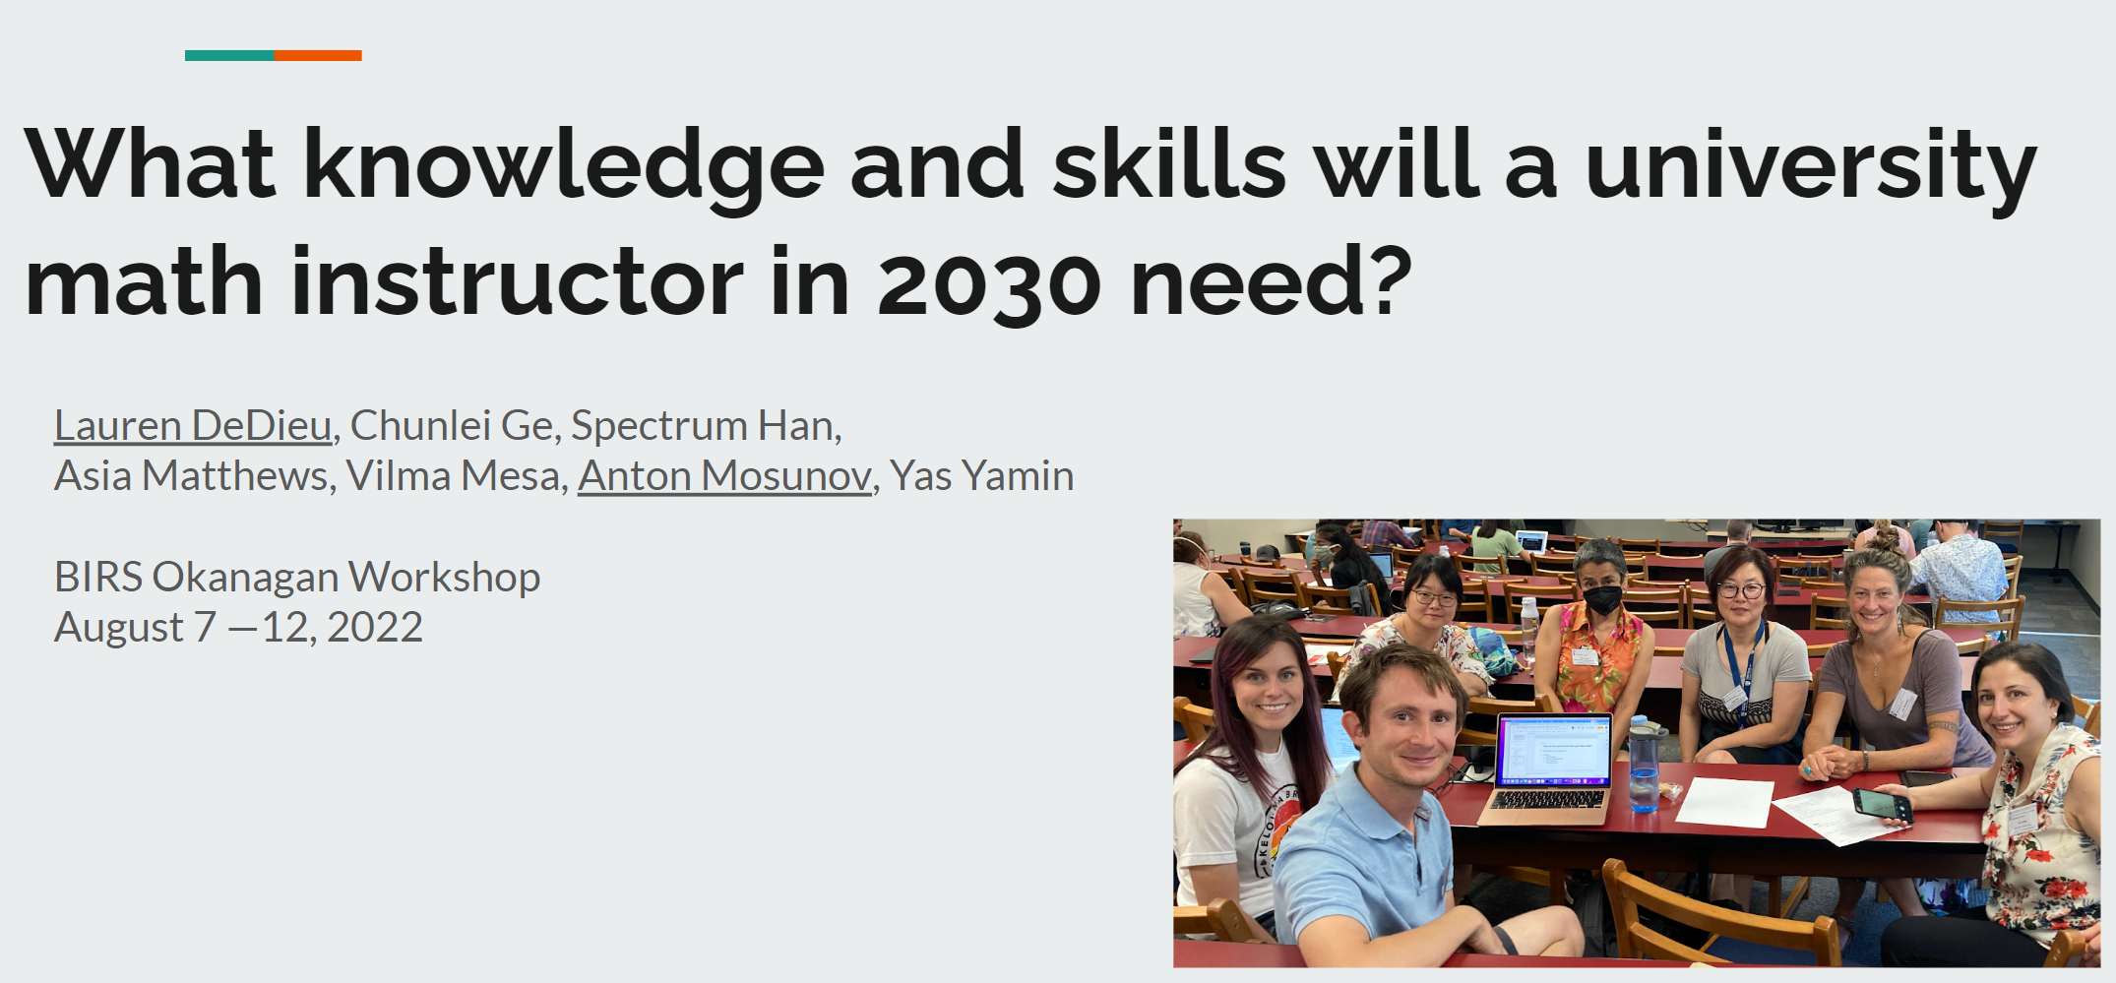
Summary (Our Presentation Slides):

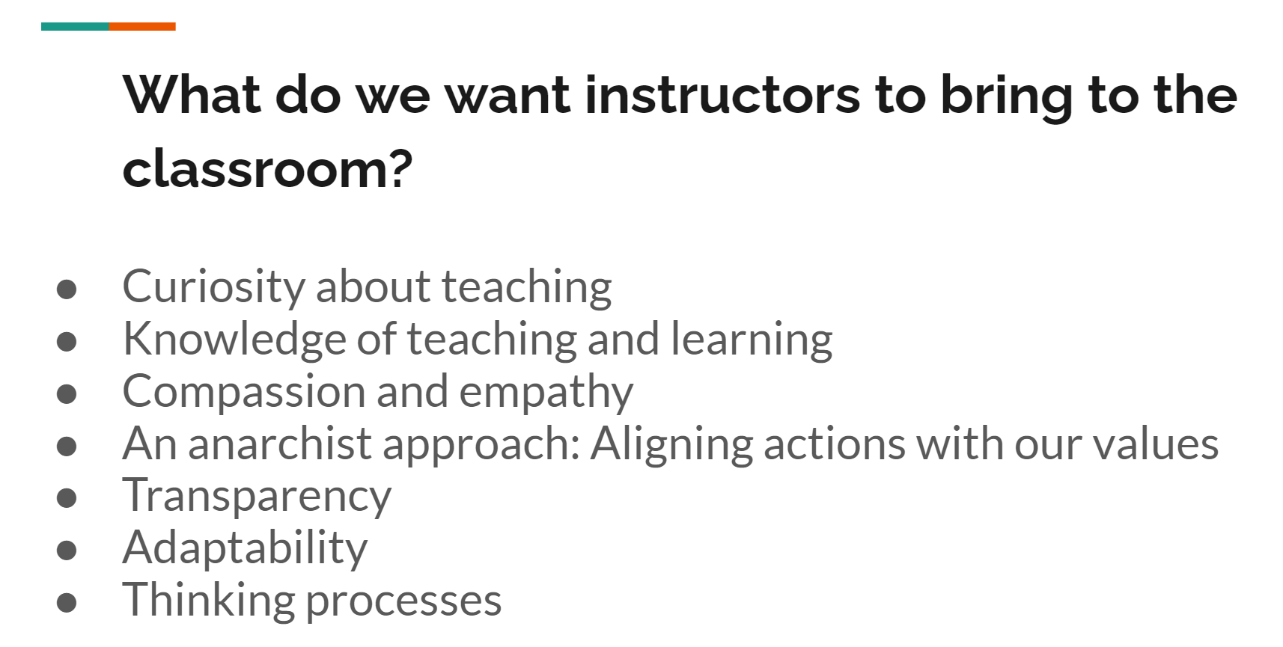

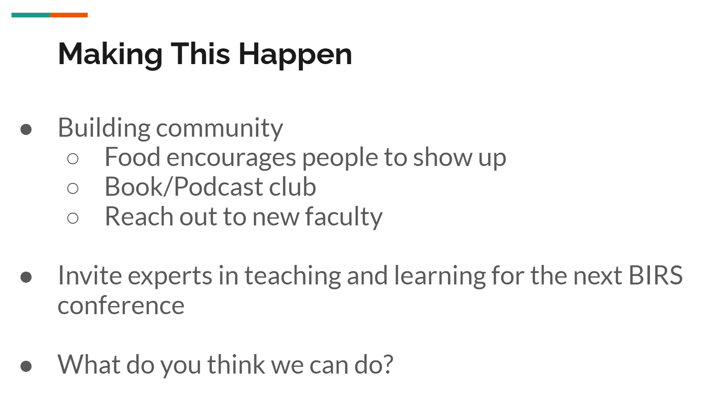
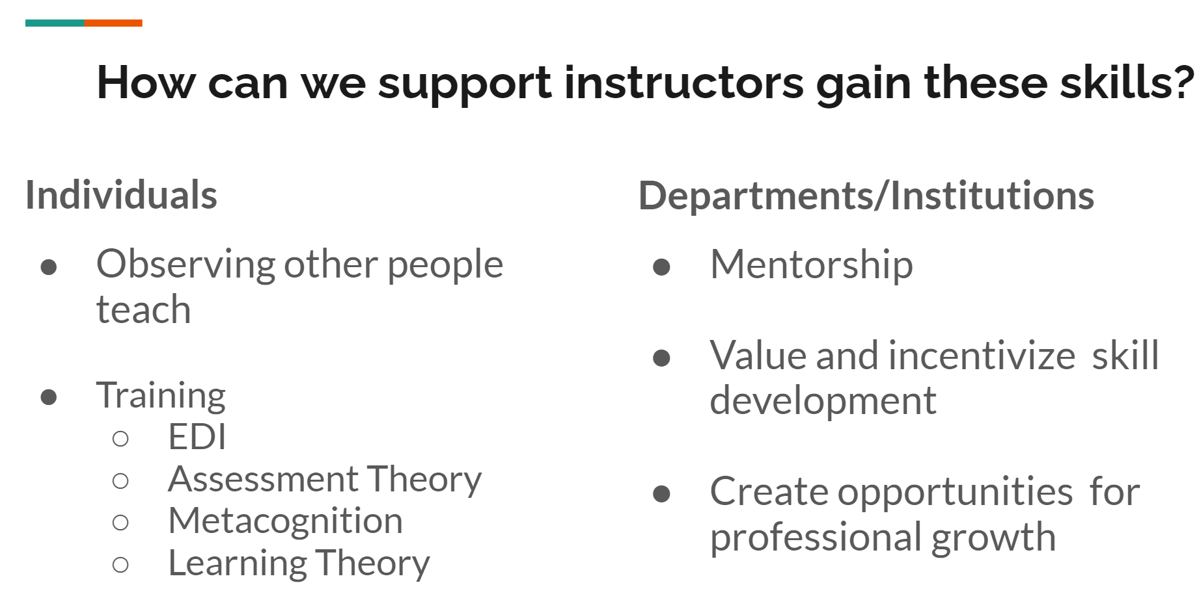
Additional Notes:

What will teaching first-year math look like in 2030:
- Learning in in 2030 will be like Duolingo… gamifying learning.
  - The game can help with this… if you already know chain rule, then don’t need to keep doing it.
  - Personalized learning platforms… customizes the questions based on your learning. (AI)
  - There’s also a program called Prodigy for elementary school students.
  - Shifting from paper textbooks to interactive textbooks

What is the role of the instructor in 2030?
- Ask questions, provide a framework… need that expert… don’t know WHY you’re doing it. Needs to be structured by an instructor… have someone to guide you.
- Assess if you really know it. Clarifying things (…what is a proof?)
- Teach students where they’re at now, and when they need it most.
- Telling students the WHY. Give them perspective. (e.g., Why do I keep emphasizing this definition again and again.)
- Adaptability: Challenge students. (Learning is uncomfortable.)

Skills First-Year Instructors Should Have/ Things They Should Do:
- Adaptability: We can’t change our students… we are the ones that need to change. (i.e., the ones that are sitting in front of us in class… work with what you have.) Challenge students at their capacity as opposed to lowering standards, being flexibility).
- Soft Skills/Virtues: Helping students develop soft skills/virtues (e.g., their metacognitive skills: learning how to learn, communication skills, etc.).
- Compassion and empathy:
  - Helping students understand that just because you did poorly on an exam, it doesn’t say something bad about you or about how well you are at math… it’s just a reflection of how much you know in this moment.
  - Pure mathematicians… praise the genius and the child prodigy. Doesn’t accept anything but brilliance. They don’t know what the first-year experience is… their first-year experience was SO different. The decisions they make are impacted by this (…skip things). Brilliance is praised among research faculty. But are we able to recognize brilliance among, say, Muslim students, victims of war, who are on their path of learning English?
- Understanding theory of assessment: An important skill for an instructor to have is understanding how to make a good assessment (e.g., Mastery Grading Group, mastery grading, specifications grading, oral exams, summative vs formative assessments, sustainable assessments, upgrading, portfolio building, transferring student attention from grades towards feedback). Be able to evaluate students’ work. (See what the common mistakes are… have students evaluate the faculty work to see what’s wrong… make this into an assessment.)
- Thinking Processes: more focus on this.
- Transparency, humanizing, trust… connection between students and instructor (tell students what we are doing and why we are doing it, establishing connection with them, provide humanising experience, be clear about your expectations, explain what topics are important and why, build strong relationships, not making assumptions about our students)
- Training in pedagogy: Instructors should be aware of professional pedagogical language and share this language with students (e.g., Bloom’s Taxonomy… give them the language to express these complex levels of learning. Types of Knowledge: factual, procedural, conceptual, metacognitive; 6 cognitive processes: remembering, etc.; Affective Component.)
- Mathematical Knowledge: Need knowledge of the mathematics for choosing problems (or for scaffolding) and for understanding student work.
- Inclusivity: Make our classrooms more inclusive (e.g., is it all boys answering the questions)? International students (…want to contribute, but takes longer to take everything in, and by that time the conversation has moved on.) Allowing students to speak their own language. Need to be more open to learning our students’ strengths and encouraging them to bring them out. (e.g., presenting their solution in their own language.) Need to meet our students where they are.
- Knowing the Full Picture: Want to know what math our students are going to need. (e.g., the engineers will need this; the physicists will need that in their future courses.) Instructors are stuck in our bubble.

How can we help instructors obtain the skills we care about?
Training:
- watching other people teach (positive and negative ideas… what you want to do and not do… important to have guidance… analogy of watching a movie passively vs. if you went to film school… you notice where the camera is and the lighting),
- learning about assessment,
- EDI Training: Inclusive STEM Teaching Project (Mooc)… meet with a small group and discuss.
- Awareness of other tools in the toolbox (e.g., active learning, learning about education science)
E.g.,
  - Something like Project NeXt?
  - Taking a math pedagogy course.
Debate about getting feedback on teaching… some people aren’t ready for the feedback yet.
Framework: Planning (establish learning outcomes), Teaching, How do you know what they’ve learned?
Step 1: Figure out how to develop a good lecture. (…don’t do active learning yet.)

Junior Faculty
- Need a mentor!
- Making expectations clear for new faculty (e.g., don’t need to answer discussion board questions at 11pm)
- Senior faculty to set good examples (e.g., encourage new faculty to take vacation time, not sending emails at weird times).
Ongoing Practice:
- The Department/University should value things and provide incentives to do it… e.g., a box on annual review to say how you’re supporting EDI, how you’re innovating your teaching.
- Room for professional growth (e.g., room to do a little research if you want, room to develop a new course, room to teach new courses instead of teaching the same courses year after year after year after year.) Support with time and money.

Actionable things we can do so that they become a reality by 2030:

- Lack of community and support. (For my craft, as a human being.) Faculty culture. Lack of connection.
Solutions:

  - Food encourages people to come! E.g., Pay for lunch for faculty to get together and talk… less expensive than the students failing and leaving campus. Funding for food for a reading group about teaching… create a learning community.
  - Make a buddy.
  - The presence of faculty who cared about teaching deeply and were an inspiration.

Side Discussions:
Assessment:
- The moment we put a number, it hurts the learning.
- Grading for growth (mastery-basted grading)
    - Identify the ways you want students to grow… pass or revision… better for students because the feedback is so much more valuable… and the grading is faster. Mark it in front of students… say everything that’s in your head as you go through it… to clarify expectations.
    - The exchange system is different… there’s still a contact, but the currency is different.
    - A proof is either correct and well-written, correct and not well-written, incorrect. Give one more chance to resubmit.

Streaming Calculus:

- Should we stream calculus? (UBC… same calculus for everyone, but smaller sections once per week and pick it based on the types of problems you want to solve… have physics tutors in the physics section to lead this.) Mathematics instructors aren’t science experts… and shouldn’t be expected to know this skill.
- Like many people have math anxiety, we as instructors have science anxiety. Should we counter science anxiety? Or is it not our job to teach, say, examples in physics or chemistry? Isn’t it more authentic to ask physicists and chemists teaching them, since this is more authentic.
Remove the hierarchy:
- Research vs. teaching: conflicting. A human only has so much potential. It’s fine for us all to exist simultaneously. Removing any sort of hierarchy there.
- Some instructors don’t like teaching first year students because they don’t like babysitting. But is babysitting bad? Does it have to be called this way?

Resources:
- Great talk on assessment: https://uofwaterloo-my.sharepoint.com/:v:/g/personal/zcramer_uwaterloo_ca/EXlP_4v0iHFChrdTv0FrEmcB_-Rj2PjcPl5uJtCmG6Vriw
- Book that might be useful to read: https://en.wikipedia.org/wiki/Bullshit_Jobs
- Vilma told a great story about allowing students to work in small groups, talking in their native languages.

